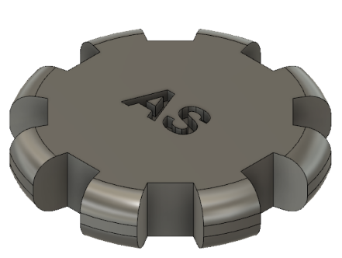
In this training, we are going to learn enough about computer-aided design (CAD) to be able to digitally create a 3D object. This file that we create can then be sent to a 3D printer, in the Tulane MakerSpace or elsewhere. This is a screenshot of a 3D print of the object we’ll be creating:

The object will be designed with the help of Fusion 360, a free 3D modeling software. If you have not downloaded Fusion 360 already, you may do so by navigating to the following web address: https://www.autodesk.com/products/fusion-360/students-teachers-educators

Since computer screens are 2D, the guide will start with navigating 3D space on a 2D screen and end with successfully making a part that is ready to be post-processed into a tangible object. It is expected that you could complete this guide on your own, but in today’s training you may ask a Maker Ninja if you get stuck on any parts.

GETTING FAMILIAR WITH FUSION
To begin, open Fusion 360. You will be greeted by a gridded plane. This is called the workspace.
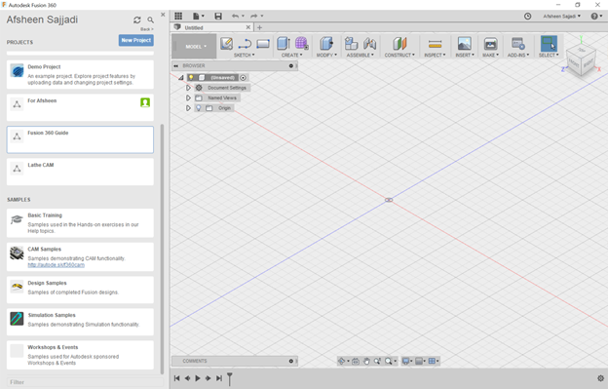
On the left, there is a sidebar called the Data Panel which contains your project library, where you can organize your different projects by folder. This sidebar also contains several additional samples and tutorials. At the upper left corner of the Data Panel, your name should be shown.
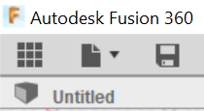
If the sidebar isn’t shown, but the gridded plane is visible, click on the Data Panel button , which looks like a grid of 9 squares. This button is found in the upper left corner of the program.
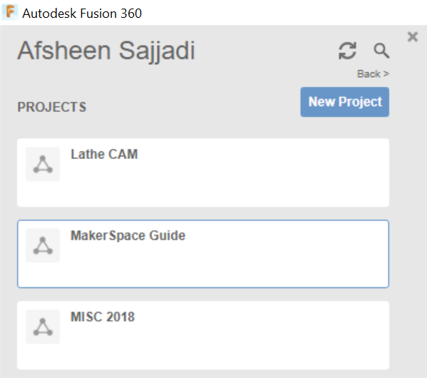
Click on the blue button to create a new folder. Name this folder “MakerSpace Guide” for this walk-through. Double click on the your newly created project folder, visible in the sidebar, to show the empty file directory. Here you can upload any files that may be relevant to the project to keep organized.
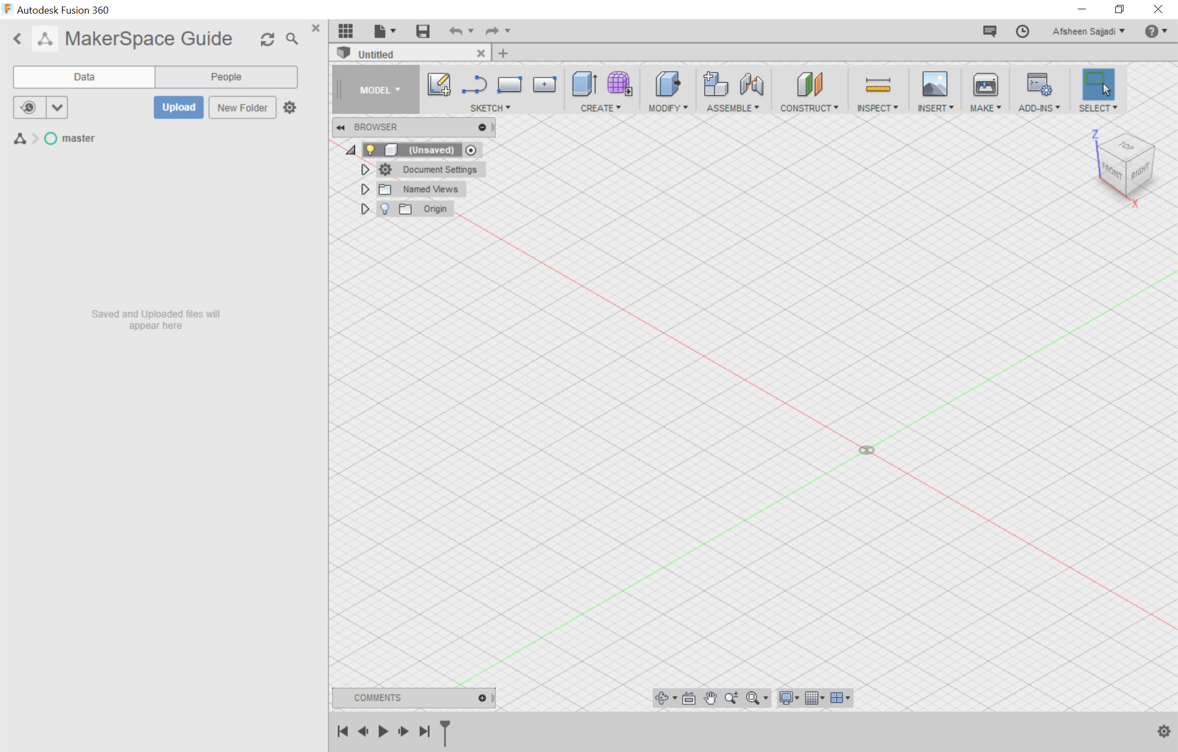
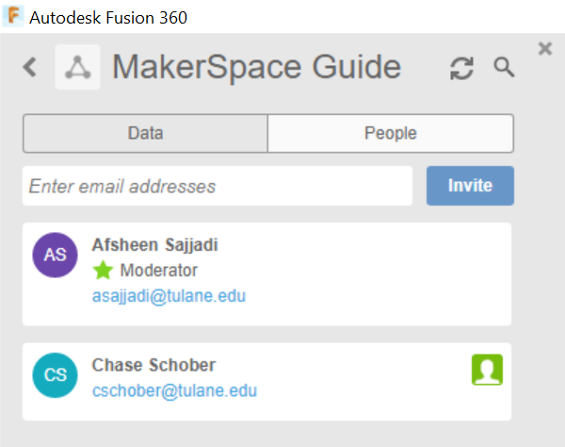
It is important to note that you can actively share your project for group collaboration efforts by clicking the “People” tab next to “Data”. Here you can invite the emails associated with your group member’s Fusion 360 accounts. Let’s close out the project sidebar/data panel so we can use the entire screen for viewing the model. Click on the data panel button in the upper left of your workspace to hide the data panel.

Next, click on the file button just to the right of the data panel button in the upper left corner of the program. Select on save to bring up a popup. Save the current file as MakerCoin, making sure that the location shows MakerSpace Guide.

This is the project we just created. All changes made to the model are actively saved to the cloud if you are connected to the internet. Otherwise, the changes to the model will upload to the cloud next time that you open Fusion 360 when you are connected to the internet.

Before we get started with our model, let’s make sure our system of units is what we desire. For this model, we will be working in imperial (English) units, with our unit of measure being inches. Why inches? Because that is what most machinists in the America and their equipment use and it makes compatibility easier with commonly sold parts like screws.

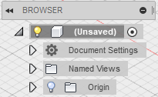
To verify our system of unit, look under the floating browser menu in the upper left corner. There will be an option for document settings. Click on the arrow to the left of this option to expand its menu.

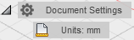
The Units option should now be shown along with the current measurement system for length. In my case, this says “mm,” but your units may be different. We want to change this to say “in” so that inches are our base unit for our measurement.

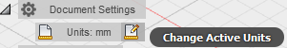
If you hover over the words “Units: mm”, a button will appear to the right of the word.
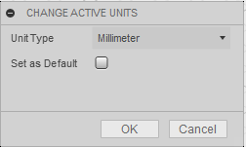
Click on this button and a window should appear called “Change Active Units”. Click the dropdown menu next to unit type, and select “Inch”. Click ok, and your units will now be set to inches.

Now let’s get oriented with moving around in the workspace. Use your mouse to zoom in and out by scrolling. If you have a laptop with a trackpad, you can use pinch to zoom.

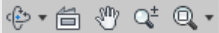
You have several options to change the view. The first option is to use the free orbit tool 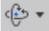 located in the Navigation Bar at the bottom of your screen. Click on the free orbit tool and then click and drag anywhere on the gridded workspace to observe the changes in the view. The pan tool 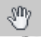 will allow you to basically slide your view from left to right as well as up and down. The pan tool mirrors the motion of a person when they turn their head on their neck from left to right. The second option you may use to change your view requires the use of an external mouse with scroll wheel and middle mouse button. This is the option that most people prefer. Click and hold the middle mouse button while dragging to pan your view of the gridded work-space. You can also pivot the view if you hold the Shift key while using the middle mouse button. The ViewCube in the upper right corner allows you to quickly change your perspective to certain views, as well as freely manipulate your view. In the upper right corner, hover over the ViewCube and click the home button to reset your view of the 3D workspace. To see other perspectives, left- click and drag along the faces, edges, or corners of the ViewCube to center your view along that plane. By clicking and dragging on the box, you can pivot your view about the origin (the dot in the middle) which indicates the x, y, and z coordinates to be zero.

STARTING A SKETCH
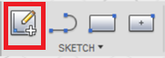
Now that we can move around, let’s start building our model. First, we’ll create a cylinder with a height of ½ inch and a diameter of 2 and ½ inches. Click on the Create Sketch button on the leftmost part of the SKETCH tab on the upper toolbar.

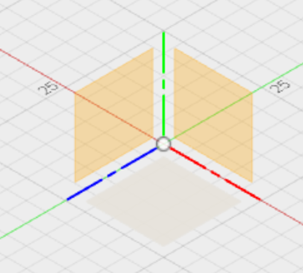
A sketch is a 2-dimensional object. Fusion 360 can place our 2-dimensional object in any of three planes, but we need to tell it which plane to work in. The three squares representing the 3 different default sketch planes should show up in the middle of the screen. Click on the lowermost sketch plane. This means we will start building our model from bottom to top. The view should automatically change to an overhead view typically denoted as “top view”.

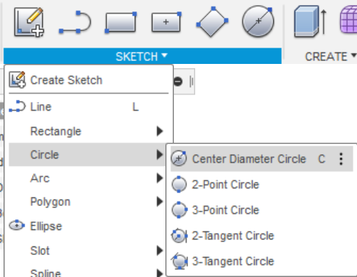
Next click on the SKETCH drop down menu. As you can see there are a lot of options to draw your design. Hover over the Circle option and click on the Center Diameter Circle button. Any circle type will work, but for our purposes, we want our model to be built centered around the origin point. The other options are primarily for designs where we are creating circles in reference to other shapes and objects.
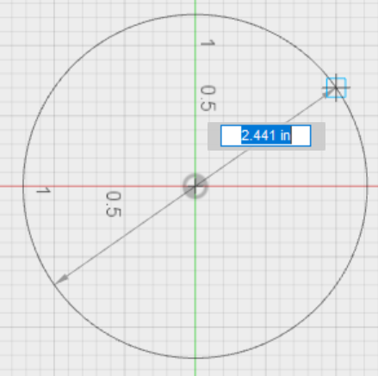
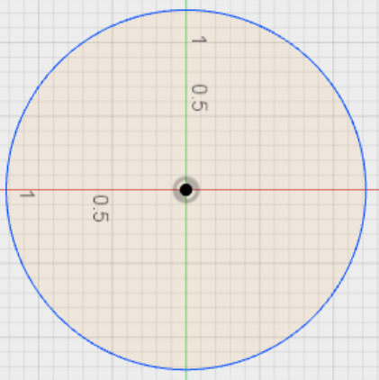
Next move your cursor to the center point. Click and drag your mouse outward and see the circle expand. You also will see a highlighted box with a diameter measurement appear. To finish the circle, click anywhere on the screen to generate the circle. We want to dimension the circle to get the specific diameter we desire. Dimensioning the circle makes the diameter a parameter that can easily be adjusted in the future.
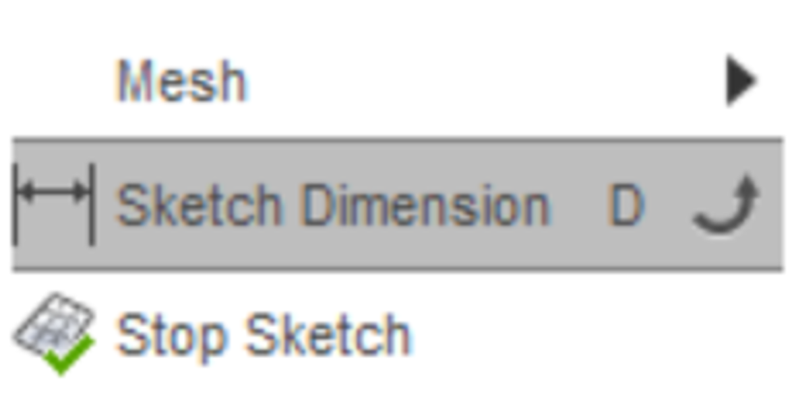
Click on the SKETCH drop down menu, and at the bottom, click on Sketch Dimension. Next, click on circle’s blue border to get the dimension and then click outside of the circle to verify the dimension. This will allow you to type a diameter of 2.5 inches and hit enter to set it. Please note that you can type simple math in this box to get half of a dimension or adding 3 inches, which can be useful in some cases.

Go back to perspective view by clicking on the Home button. This is found by hovering over the ViewCube in the upper right corner.

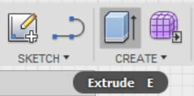
EXTRUDING A SKETCH
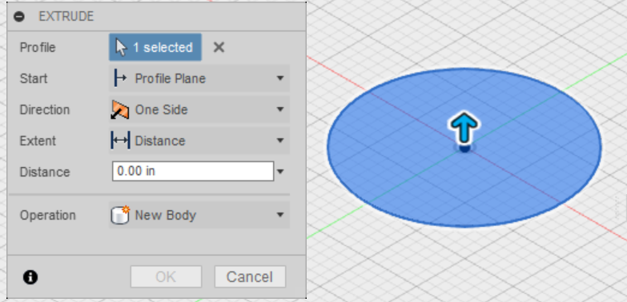
Next, we will take our 2D sketch and turn it into a 3D model by extruding it. When you look at the end of an open tube of toothpaste, you see a 2D circle. By squeezing the tube, you extrude the toothpaste into a 3D cylinder. Click on the Create menu and Extrude tool will be activated. Then click anywhere in the circle to select it. An arrow will appear along with the extrude menu.

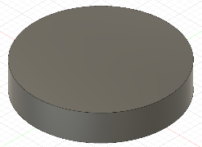
The distance option in the extrude menu allows for precise control over how tall a structure is created from the 2D sketch. Instead, here we will click on the arrow and drag the mouse upwards to extrude the model until the box on the right reads 0.5 inches. Hit enter to finish the extrusion. Your circle is now a shaded gray cylinder.

Notice how at the bottom of the screen there is a row of icons that acts as a timeline. You can move the progress bar from the right to go back along your design and hide features that you made. If something is built atop another, you can also delete features that you may no longer desire. Right‐clicking on a feature allows you to change values and make various edits. For example, if you want to increase the height of the base cylinder, then right click on the first extrude feature to change it. The play pause forward backward buttons allow you to watch how your model was built up, step by step.

ADDING A FILLET
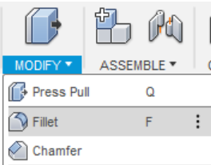
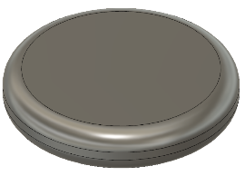
Now that we have a 3D object, we will use this cylinder as a base around which we will build up the rest of our 3D model. The edges of the cylinder are sharp we will round off these sharp edges using fillets to get more of an aesthetically pleasing coin. A fillet (pronounced “fill-it”) is a rounded edge. To begin, click on the fillet tool under the modify menu which will open the FILLET window.

Click on the upper and lower edges of the cylinder, so the edges turn blue. Once selected, type 0.2 to set the fillet radius to 0.2 inches. The number of edges and the size of the edge radius will appear in the FILLET window. For the purposes of this tutorial, we don’t need to modify the rest of the options available in the FILLET window. Click 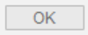 to finish adding the fillet.
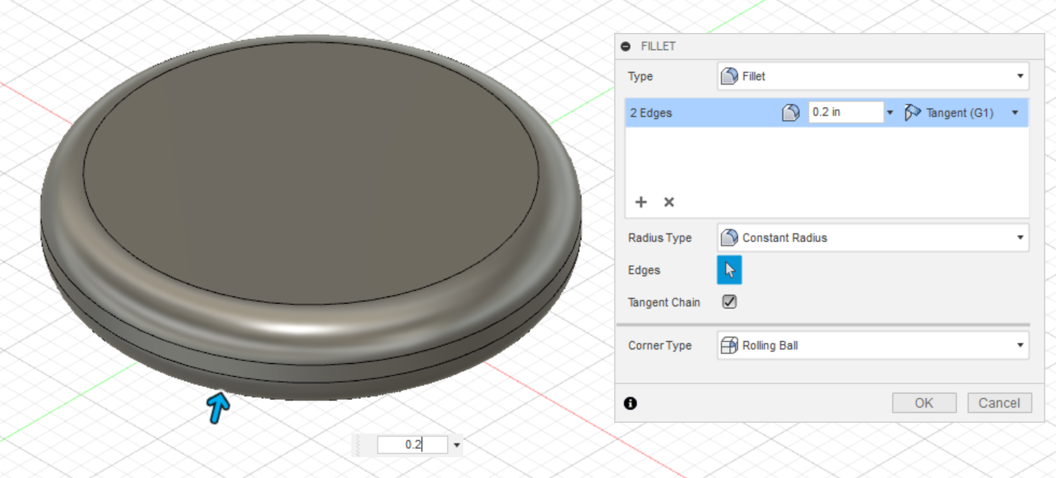

SKETCHING A TRAPEZOID
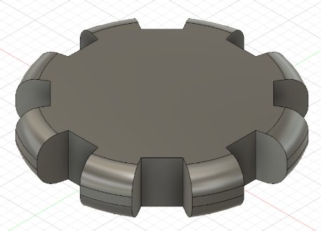
Now that we have a smooth coin, let’s add some unique features. First, let’s create notches around the coin to make it look more like a gear.

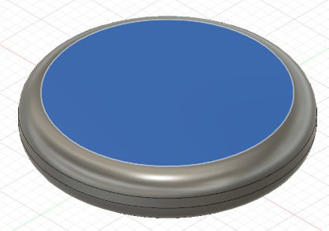
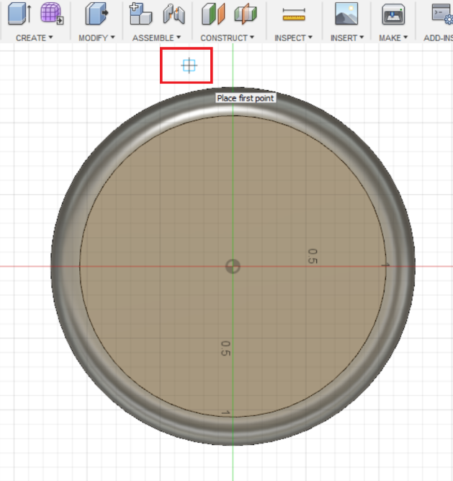
To begin, we need to sketch a trapezoid on the top of the coin with which we may cut. We need to select a surface from which we can continue to manipulate our model. Click on the top face of our cylinder to select it. We will use the line tool to draw and connect 4 lines to make a trapezoid.

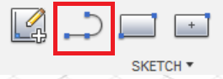
With the top face of the cylinder still selected, click the Line tool in the SKETCH section. The view will change to the top face. Scroll out slightly with your mouse to have the area around the top face in view. Click just outside of the cylinder near the top face to set your first point. The point should be in that general area, but we will use a tool later to more accurately position it.
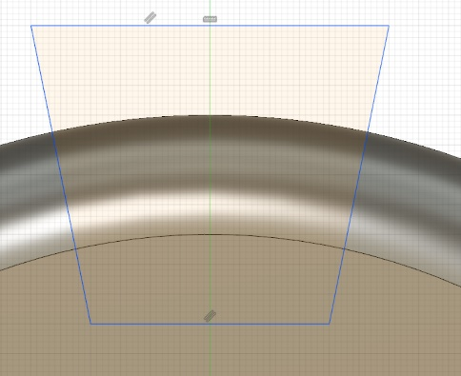
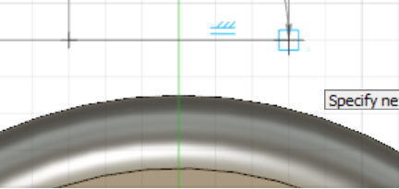
Now with your first point chosen, horizontally move your mouse to the right past the vertical green line and select a point. The last two points of our trapezoid will be inside the cylinder. Once you create those points, click on our first point to complete the trapezoid. The interior of the trapezoid yellow.
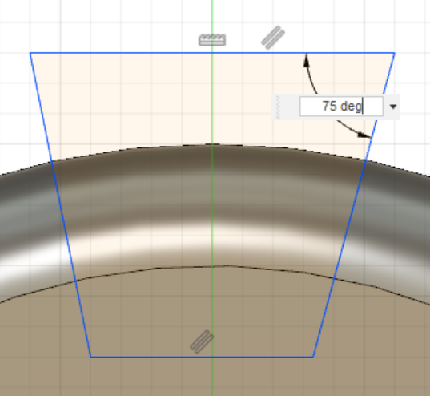
Now that we have a trapezoid, let’s make it more symmetrical by adding dimensioned angles. We will use the Sketch Dimension tool to accomplish this. Click on the SKETCH button to open the SKETCH drop-down menu. Near the bottom of the menu, click on Sketch Dimension. Next, click on the top line of the trapezoid and then click the right side of the trapezoid. An arbitrary angle dimension will appear. Click on the inside of the trapezoid so you can type the angle. Feel free to choose any angle you want, but for the purposes of this tutorial, I will choose 75 degrees. Repeat this procedure for the angle between the top line of the trapezoid and the left side of the trapezoid.

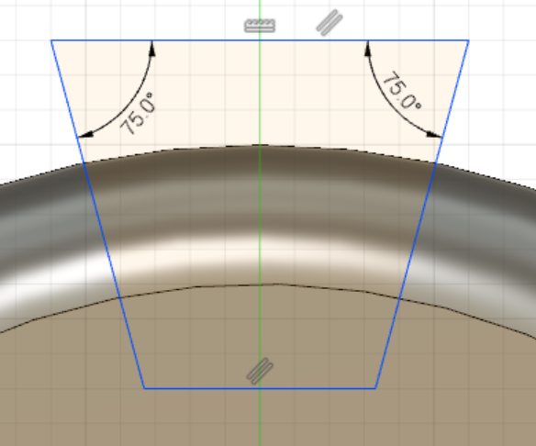
MULTIPLYING TRAPEZOIDS
To get the gear aesthetic we are looking for, we need to make 7 more of these trapezoids. Luckily, we don’t have to make the rest of these by hand. We can use the Circular Pattern tool in the SKETCH menu.
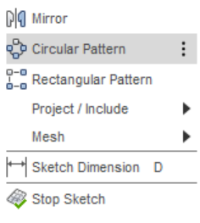
Click on the SKETCH button to open the SKETCH drop-down menu. Near the bottom of the menu, click on Circular Pattern. The CIRCULAR PATTERN window will open. Starting from outside the trapezoid, click and drag over the whole trapezoid to select it. All the vertices and edges of the trapezoid should become highlighted. Then next to the Center Point text in the CIRCULAR PATTERN window, click on Select. 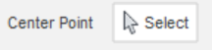. Now, click on the center of the cylinder 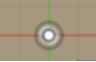 to select it. This will make the trapezoid evenly pattern around the cylinder.
Finally, for the Quantity in the CIRCULAR PATTERN window, type 8 in the box, so we will have a total of 8 trapezoids distributed evenly around the cylinder. Click to finish the circular pattern.
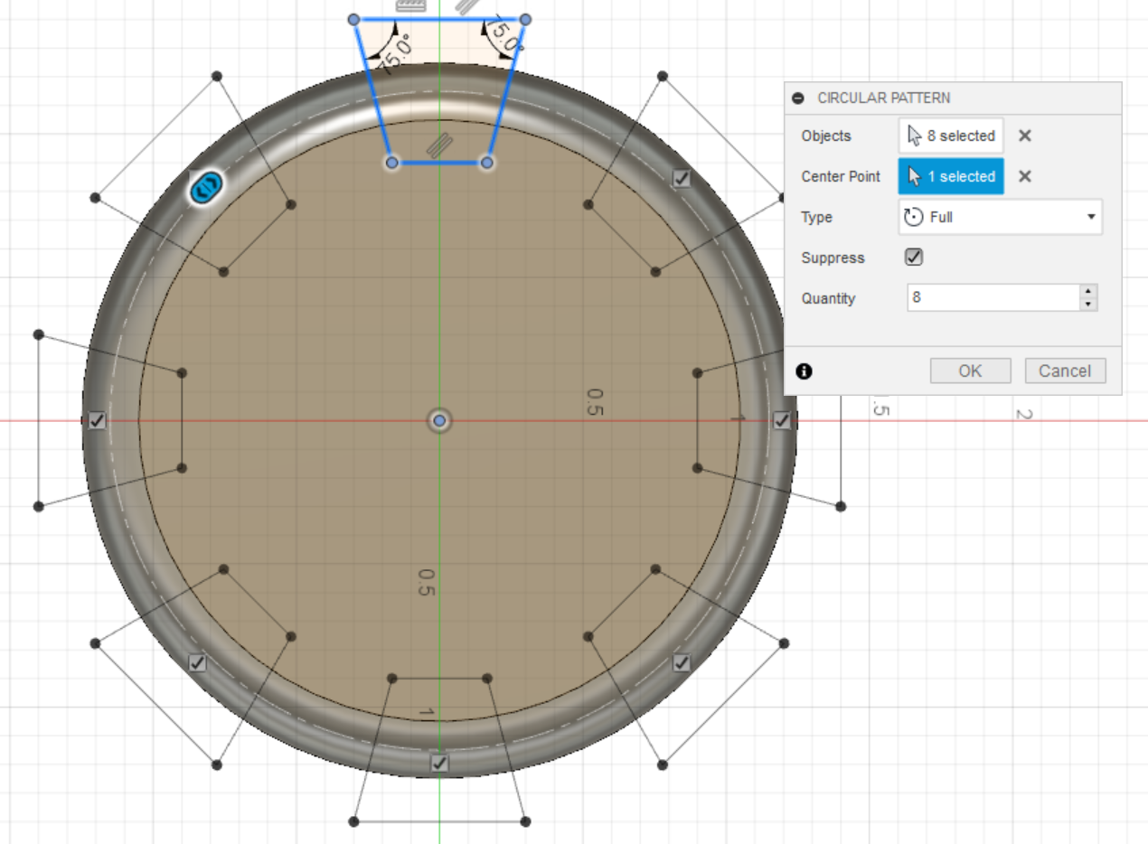
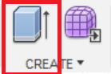
CUTTING THE TRAPEZOIDS
Great, now we have a bunch of trapezoid sketches, but we need to cut them out of the coin to get the gear aesthetic we want. To begin, let’s click on the Extrude tool in the CREATE section of the toolbar. The EXTRUDE window will pop up, prompting you to select the sketches to cut or extrude. Click on each of the trapezoids. Notice when you click the trapezoid, it is split into 2 regions. This is because the Extrude tool is also considering the circle around the cylinder created by the fillet to be part of the sketch. Click on both regions of each trapezoid. Once you select all aspects of the trapezoids, it will prompt you to set an extrude amount. Since we want to cut, type -0.5 in the box. . Click to finish the cut.
If you make a mistake, you can use the undo button in the upper left corner. This will undo features, sketches, and dimension changes, but not necessarily an accidental edge selection. In those instances, if you are in the fillet or chamfer menu, you can just click the edge again to deselect it.

ENGRAVING YOUR INITIALS
Select the top face of our model. Click on the SKETCH button to open the SKETCH drop-down menu. Near the middle of the menu, click on Text. Click near the center of the cylinder, but not the exact center. The TEXT window will open. Type your initials in the first box. Change the height to 0.5 inches. Additionally, bold your text by clicking on the B icon. I set my angle to 180 so it would be right side up on my screen, but it’s not critical. Click to finish writing the text. You can proceed to move the text to better center it by clicking and dragging the text around.
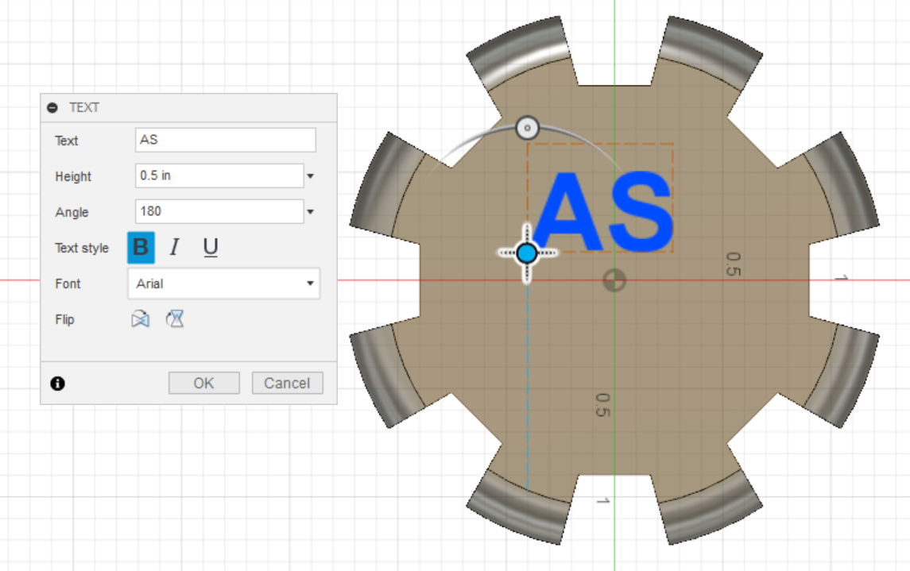
Click on the Extrude tool and select your text. Type -0.20 to engrave the text into the model. Since this value is less than our model height, it will only be inset into the model. Go back to home view by clicking on the Home button .
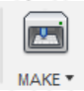
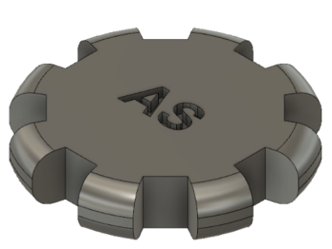
You now have a completed part ready for simulation, animation, or just presentation. To export your parts as a 3D printable file, click on the 3D print tool in the MAKE section of the toolbar. The 3D PRINT window will open. Click on your model to select it for export.
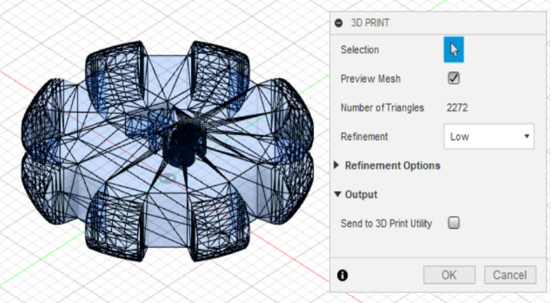
This will save your part as a mesh file which is composed of many triangles as you can see by clicking Preview Mesh. For our purposes the default settings are fine. Uncheck Send to 3D Print Utility under the Output tab if it is checked. We do not want to send the file to another program, rather, we want to save it as a 3D printable file. Click , and a window will pop up asking you where to save the file.

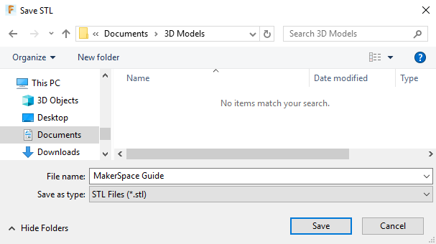
Using this save window, navigate to the location that you want to save it. In my case, I will save it to a folder called 3D Models in My Documents to keep my 3D printable files from Fusion 360 organized. Once you have picked a location, click ok and the 3D printable file should immediately save to the location you chose. Notice that 3D printable files have a file extension of .STL similar to how Microsoft Word documents use a file extension of .docx. This .STL file can be now be moved to a USB and imported into Cura in the MakerSpace to prepare it for 3D printing.

